Activating SAML sample in BA-server

Note: Activating SAML sample explains how to enable the SAML logic, regardless of which IdP we choose to use as a means to perform user authentication

SAML: Overview

SAML is mostly used as a web-based authentication mechanism as it relies on the browser being used as an agent that brokers the authentication flow. At high-level, the authentication flow of SAML looks like this:

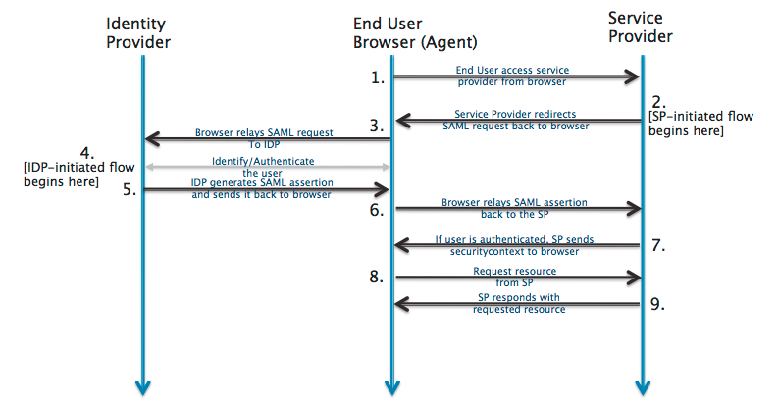

Identity Provider | SSOCircle.com , OKTA, … | The 3rd-party entity that takes care of the user’s authentication; There are multiple such entities with SAML protocol support, such as OpenSSO, SSOCircle.com, OneLogin.com, Salesforce.com, …
End-user browser agent | Pentaho User | User that accesses BA-server via browser
Service Provider | BA-server | Pentaho BA Server

Pre-requisites for SAML authentication provider sample

- Complete one of the following documentations:
  - “Registering in SSOCircle IdP”
  - “Registering in OKTA-developer IdP”
  - “Registering in PingIdentity IdP”
  - “Registering in Salesforce-developer IdP”
  - “Registering in MS ADFS 3.0 IdP”

- Have the following 3 items of information:
  - The URL for the chosen 3rd party identification provider (IdP)
  - The absolute path to the chosen’s IdP metadata xml file
  - The absolute path to Pentaho SP metadata xml file
    - Next to this document, you should have a “resources” folder. Inside it you will find a standard Pentaho SP metadata xml for download.

- Pentaho-SAML OSGI .kar file
  - git clone https://github.com/pentaho/pentaho-engineering-samples
  - Navigate to /Samples for Extending Pentaho/Reference Implementations/Security/SAML 2.0/
  - Maven build the .kar file ( “maven package” )
  - OSGI .kar file built and created in (…)/SAML 2.0/pentaho-saml-assembly/target
Preparing BA-server for SAML authentication provider sample

Note 1: Use BA-Server EE 6.0.0-GA build

Note 2: This section includes preparation tasks, i.e. tasks that only need doing once

- Edit pentaho-solutions/system/karaf/etc/custom.properties:
  - find “org.springframework.security.context, \” and replace it with “org.springframework.security.context; version\="2.0.8.RELEASE", \”
  - below the line above add a new one: “org.springframework.security.ui; version\="2.0.8.RELEASE", \”

please ensure that both lines end with the “, \” ( comma, whitespace, backward slash ), as stated above.

- Start BA-server
- Next to this document, you should have a “resources” folder with 3 files:

- pentaho-sp.xml
- applicationContext-spring-security-saml.xml
- logout.jsp

- Place the built pentaho-saml.kar file into pentaho-solutions/system/karaf/deploy
  - check log files to see if all went well; you should see a line stating:
Creating configuration from pentaho.saml.cfg
  - look into pentaho-solutions/system/karaf/etc
    - you will notice a pentaho.saml.cfg file was created

- Stop BA-server.
- Place applicationContext-spring-security-saml.xml in pentaho-solutions/system
- Place logout.jsp in tomcat/webapps/pentaho
- Edit pentaho.saml.cfg and update the following 3 keys with the values mentioned in the “Pre-requisites for the SAML authentication provider sample” section:
- saml.idp.url : The URL for the chosen 3rd party identification provider (IdP)
- saml.idp.metadata.filesystem: The absolute path to the chosen’s IdP metadata xml file
- saml.sp.metadata.filesystem: The absolute path to Pentaho SP metadata xml file

Example:

saml.idp.url=http://idp.ssocircle.com

saml.idp.metadata.filesystem=/users/pteixeira/saml/idp/ssocircle-idp-metadata.xml

saml.sp.metadata.filesystem=/users/pteixeira/saml/sp/pentaho-sp-metadata.xml

- Save and close the file.
- Done.

Activating BA-server’s SAML authentication sample

- Stop BA-server.
- Edit pentaho-solutions/system/pentaho-spring-beans.xml
- If not there yet, place line

<import resource="applicationContext-spring-security-saml.xml" />

after all other applicationContext-*.xml lines and before the pentahoObjects.spring.xml one. Example:

(…)
<import resource="applicationContext-spring-security-jdbc.xml" />
<import resource="applicationContext-spring-security-saml.xml" />
<import resource="pentahoObjects.spring.xml" />
(…)

- Save and close the file.
- Edit pentaho-solutions/system/security.properties and change the provider value to “saml”.
  - Example: from “provider= jackrabbit” to “provider=saml”
- Save and close the file.
- Done.
De-activating BA-server’s SAML authentication sample

- Stop BA-server
- Edit pentaho-solutions/system/pentaho-spring-beans.xml
- Delete/Comment line

<import resource="applicationContext-spring-security-saml.xml" />

- Save and close the file.
- Edit pentaho-solutions/system/security.properties and change the provider value to something other than “saml”.
  - Example: from “provider=saml” to “provider=jackrabbit”
- Save and close the file.
- Done.

Q&A

Q1 | Can we add internationalization support to the logout page ?

Yes. Please do the following steps:
- Open tomcat/webapps/Pentaho/logout.jsp with an editor of your choice
- Locate the div with class “logout-msg-wrapper”
  - Its content should be something like “You have logged out of the User Console.”
  - Replace that with:
<%=Messages.getInstance().getString("UI.PUC.LOGOUT.HEADER")%>
- Locate the button with class “back-to-login-btn”
  - Its content should be something like “Return to the Login Page”
  - Replace that with:
<%=Messages.getInstance().getString("UI.PUC.LOGOUT.BUTTON")%>
- Save and close the file.
- Using a tool such as Winrar, Winzip, 7-zip, etc.., open ( do not extract ) /tomcat/webapps/WEB-INF/lib/ pentaho-platform-extensions-6.0-SNAPSHOT.jar
- Inside it, navigate to /org/pentaho/platform/web/jsp/messages/
- Edit messages.properties and add the following 2 lines:

UI.PUC.LOGOUT.HEADER=You have logged out of the User Console.
UI.PUC.LOGOUT.BUTTON=Return to the Login Page

- Redo step 7, this time for any of the other messages_<country>.properties that exist at that location
  - Add the same keys, but a properly localized message
- Save and close the files. Save and close the jar
  - At this point the extraction tool you’re using may ask you if you would like to update the jar file. Reply “yes”.
- Restart the server.

http://developer.okta.com/docs/guides/saml_guidance.html

